ESP8266 and Node-RED with MQTT (Publish and Subscribe)
Learn how to publish and subscribe to MQTT topics with the ESP8266 NodeMCU board. In this tutorial, we’ll use the Node-RED dashboard to control the ESP8266 outputs and display sensor data from the ESP8266 on its interface. The Node-RED software is running on a Raspberry Pi, and the communication between the ESP8266 and the Node-RED software is done via MQTT communication protocol. We’ll program the ESP8266 using Arduino IDE.
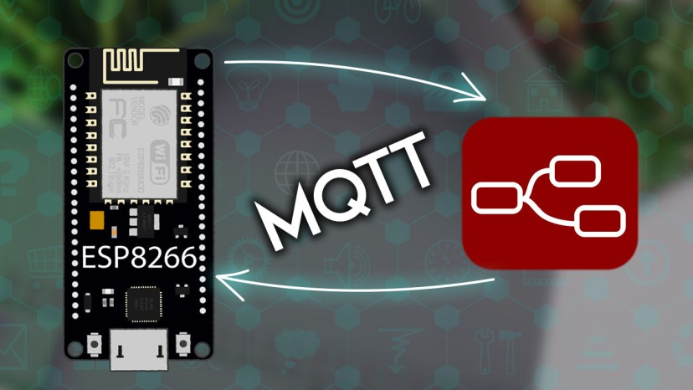
Project Overview
The following figure shows an overview of what we’re going to do in this tutorial.
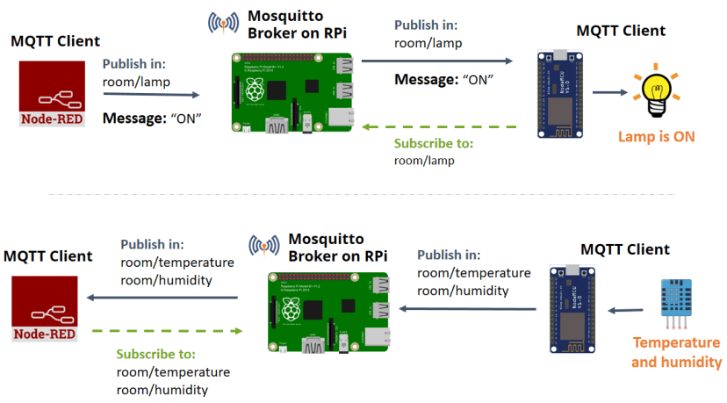
First, watch the video demonstration below
Node-RED and Node-RED Dashboard
To follow this tutorial, you need to have Node-RED and Node-RED Dashboard installed in your Raspberry Pi. Follow the next tutorials to install and get started with Node-RED and Node-RED dashboard:
- Getting started with Node-RED on Raspberry Pi
- Getting Started with Node-RED Dashboard
MQTT Protocol
In this tutorial, we’ll establish a communication between a Raspberry Pi running the Node-RED software and an ESP8266 using MQTT.
MQTT stands for MQ Telemetry Transport and it is a nice lightweight publish and subscribe system where you can publish and receive messages as a client. It is a simple messaging protocol, designed for constrained devices and with low bandwidth. So, it’s the perfect solution for Internet of Things applications.
If you want to learn more about MQTT, watch the video below.
For a written version of this video and additional resources, read this blog post What is MQTT and How It Works.
Installing Mosquitto Broker
The MQTT broker is responsible for receiving all messages, filtering the messages, deciding who is interested in them, and then publishing the messages to all subscribed clients.
There are several brokers you can use. In this tutorial, we’re going to use the Mosquitto Broker.

You can install the Mosquitto MQTT broker locally on a Raspberry Pi, on your computer, or on the cloud. Follow one of the next tutorials to install Mosquitto broker:
- Install Mosquitto MQTT Broker on a Raspberry Pi
- Install Mosquitto MQTT Broker on the Cloud (Digital Ocean)
To see if Mosquitto broker was successfully installed, run the next command:
pi@raspberry:~ $ mosquitto -v
This returns the Mosquitto version that is currently running on your Raspberry Pi. It should be 2.0.11 or above.
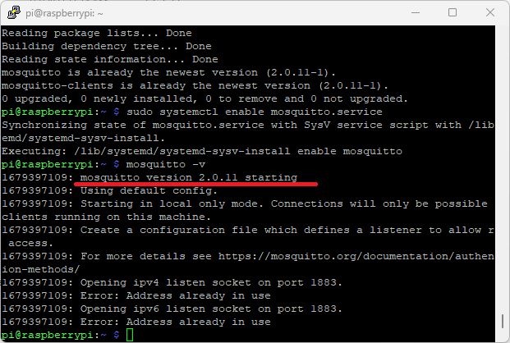
Note: the Mosquitto command returns the Mosquitto version that is currently installed, but it also tries to initialize Mosquitto again. Since Mosquitto is already running it prompts an error message. Don’t worry Mosquitto is properly installed and running if you see a similar message.
Establishing an MQTT communication with Node-RED
In this section, we’re going to establish an MQTT communication with Node-RED using the MQTT nodes.
Dashboard Layout
The first step is to create the dashboard layout. In this example, we’ll have a button to control an ESP8266 output, a chart, and a gauge to display temperature and humidity readings from the DHT11 sensor.
On the top right corner, click on the little arrow icon, and click on Dashboard.
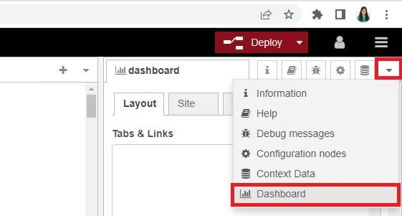
On the Layout tab, create a tab called Room, and inside the Room tab, create two groups: Lamp and Sensor as shown in the figure below.
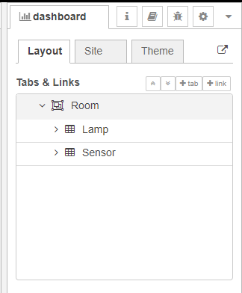
Creating the Flow
From the dashboard section at the left sidebar, drag a switch, a chart, and a gauge node to the flow. Then drag two MQTT in and one MQTT out node to the flow (they are under the network section)—see the figure below.
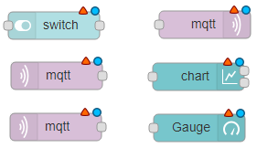
- switch – it will control the ESP8266 output
- mqtt output node – it will publish a message to the ESP8266 accordingly to the switch state
- 2x mqtt input nodes – these nodes will be subscribed to the temperature and humidity topics to receive sensor data from the ESP
- chart – will display the temperature sensor readings
- gauge – will display the humidity sensor readings
Node-RED and the MQTT broker need to be connected. To connect the MQTT broker to Node-RED, double-click the MQTT output node. A new window pops up—as shown in the figure below.
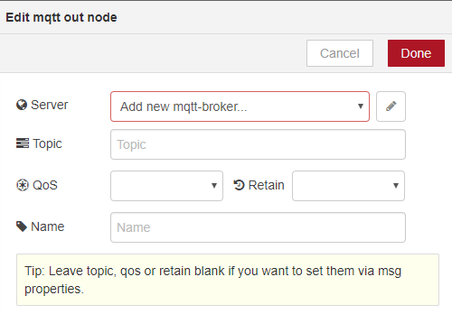
1) Click the Add new mqtt-broker option.
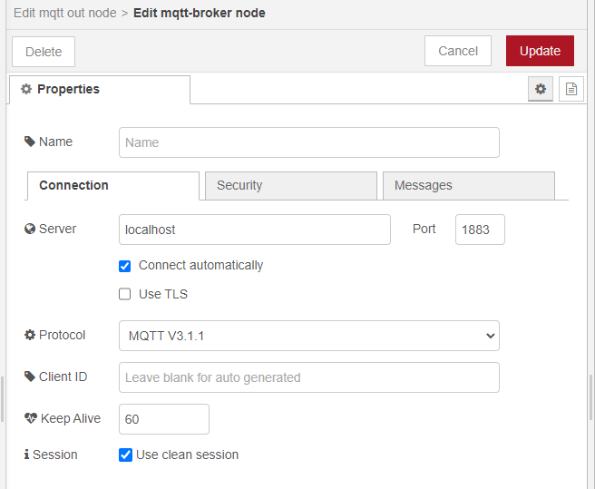
2) Type localhost in the Server field. All the other settings are configured properly by default.
If you’re not running Node-RED on the same machine that you’re running Node-RED (Raspberry Pi), insert the MQTT IP address instead of localhost.
3) Click on the Security tab and insert your MQTT broker username and password if required.
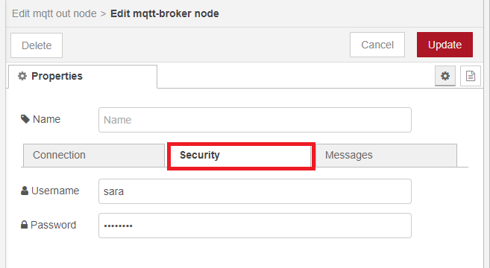
4) Press Update and then Add. The MQTT output node automatically connects to your broker after deploying the Node-RED flow.
Edit all the other nodes’ properties as shown in the following instructions.
Switch Node
The switch sends a on string message when it’s on; and sends a off string message when it’s off. This node will publish on the room/lamp topic. Your ESP8266 will then be subscribed to this topic to receive its messages. Edit the node properties as shown in the picture below.
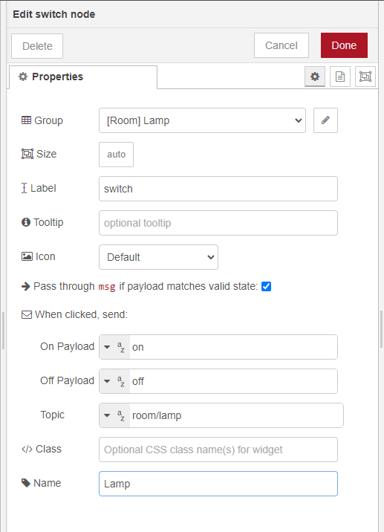
mqtt output node
This node is connected to the Mosquitto MQTT broker and it will publish in the room/lamp topic. Fill in the details as shown below. Insert the topic you want to subscribe to, set the QoS value and if you want to retain the messages or not.
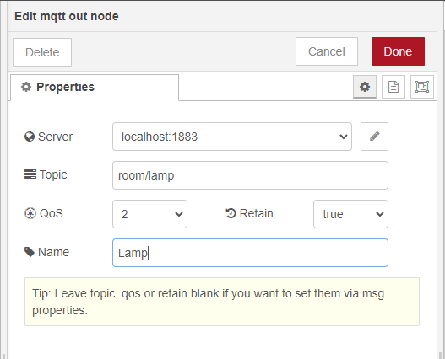
What are retained messages in MQTT? retain (true or false) what does it mean?
A retained message is a normal MQTT message with the retained flag set to true. The broker stores the last retained message and the corresponding QoS for that topic. Each client that subscribes to a topic pattern that matches the topic of the retained message receives the retained message immediately after they subscribe. The broker stores only one retained message per topic.
Why is it useful? Retained messages help newly-subscribed clients get a status update immediately after they subscribe to a topic. This is particularly useful to get the status of a device. For example, GPIO 2 is currently HIGH, and the ESP32 suddenly resets. It doesn’t know what the last state of GPIO 2 was. However, if the state is a retained message, it will receive it right after subscribing to the topic and can update the state of GPIO 2 immediately.
mqtt input node
This node is subscribed to the room/temperature topic to receive temperature sensor data from the ESP8266. The ESP8266 will be publishing the temperature readings on this topic.
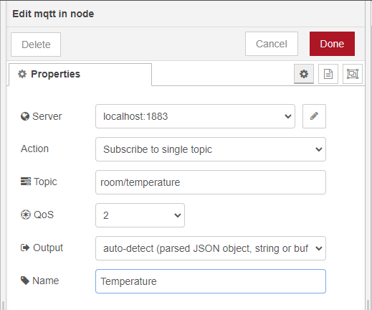
chart node
The chart will display the readings received on the room/temperature topic.
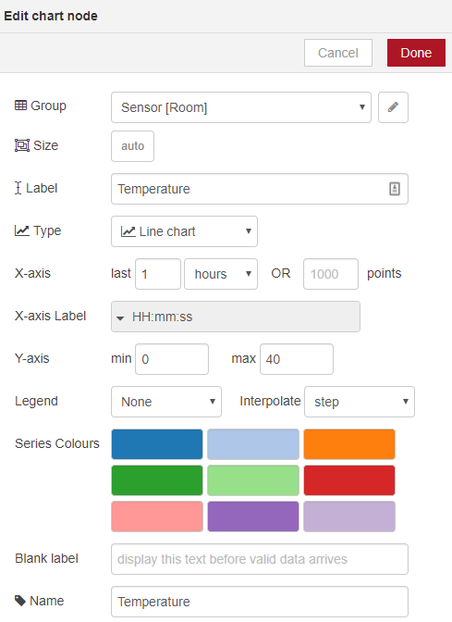
mqtt input node
This node is subscribed to the room/humidity topic to receive humidity sensor data from the ESP8266. The ESP8266 will be publishing the humidity readings on this exact topic.
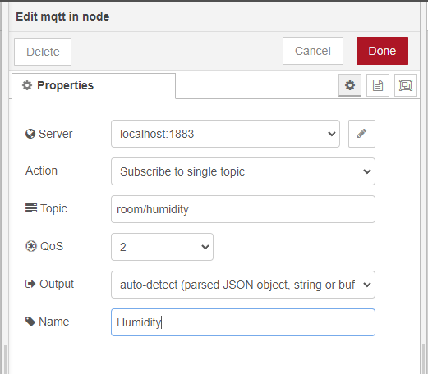
gauge node
The gauge will display the readings received on the room/humidity topic. Edit the gauge properties as shown below. You can adjust the colour gradient to your liking.
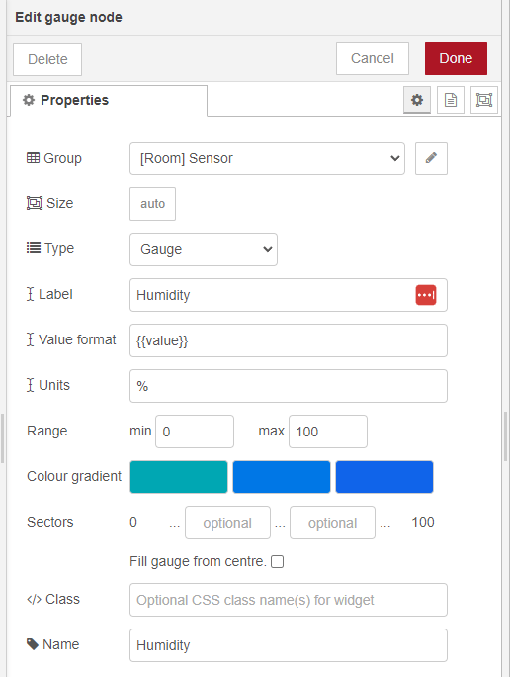
Wire your nodes as shown in the figure below.
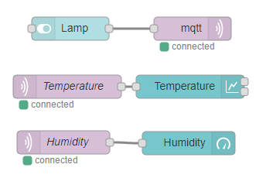
Your Node-RED application is ready. Click the Deploy button on the top right corner.

The Node-RED application is ready. To see how your dashboard looks go to http://your-pi-ip-address:1880/ui.
Now, follow the next sections to prepare your ESP8266.
Building the Circuit
The following sections show you the needed parts and schematics to build the circuit for this project.
Parts required
These are the parts required to build the circuit (click the links below to find the best price at Maker Advisor):
- Raspberry Pi – read Best Raspberry Pi 3 Starter Kits
- ESP8266 (ESP-12E nodemcu) – read Best ESP8266 Wi-Fi Development Boards
- DHT11 temperature and humidity sensor
- Breadboard
- 330 Ω resistor
- LED
- 4700 Ω resistor
You can use the preceding links or go directly to MakerAdvisor.com/tools to find all the parts for your projects at the best price!

Schematics
Here are the schematics for this project’s circuit.
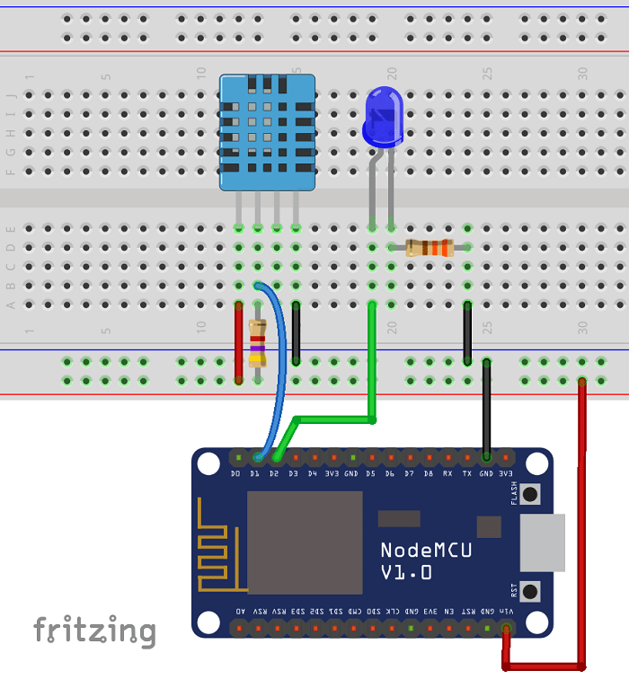
Preparing your Arduino IDE
We’ll program the ESP8266 using the Arduino IDE. In order to upload code to your ESP8266 using the Arduino IDE, you need to install the ESP8266 add-on (How to Install the ESP8266 Board in Arduino IDE). You’ll also need to install two additional libraries to have everything ready for your ESP8266.
Installing the PubSubClient Library
The PubSubClient library provides a client for doing simple publish/subscribe messaging with a server that supports MQTT (basically allows your ESP8266 to talk with Node-RED).
1) Click here to download the PubSubClient library. You should have a .zip folder in your Downloads folder
2) In the Arduino IDE, go to Sketch > Include Library > Add .ZIP library and select the library .zip folder you’ve just downloaded.
3) Restart your Arduino IDE.
The library comes with a number of examples. See File >Examples > PubSubClient within the Arduino IDE software.
Installing the DHT Sensor Library
To read from the DHT sensor, we’ll use the DHT library from Adafruit. To use this library you also need to install the Adafruit Unified Sensor library. Follow the next steps to install those libraries.
1) Open your Arduino IDE and go to Sketch > Include Library > Manage Libraries. The Library Manager should open.
2) Search for “DHT” on the Search box and install the DHT library from Adafruit.
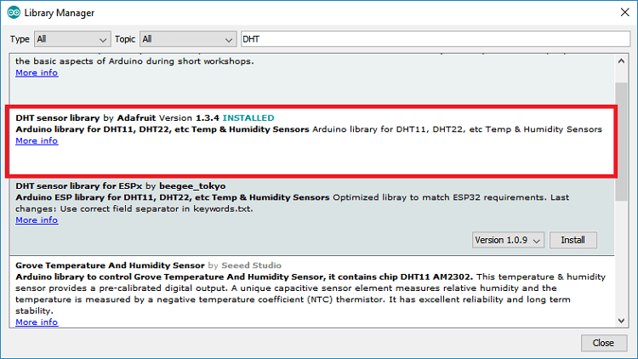
3) After installing the DHT library from Adafruit, type “Adafruit Unified Sensor” in the search box. Scroll all the way down to find the library and install it.
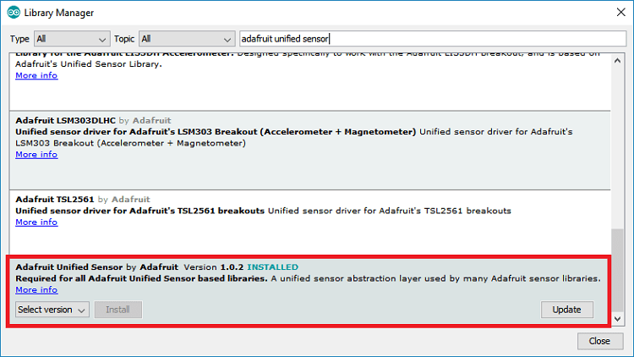
4) After installing the libraries, restart your Arduino IDE.
For more information about the DHT11 sensor and the ESP8266, read ESP8266 DHT11/DHT22 Temperature and Humidity Web Server with Arduino IDE.
Selecting the right board on Arduino IDE
You also need to select the right board on Arduino IDE:
1) Go to Tools > Board and select the ESP8266 board you’re using.
2) Select the right COM port in Tools > Port.
Uploading code
Now, you can upload the following code to your ESP8266. This code publishes messages with the temperature and humidity from the DHT11 sensor on the room/temperature and room/humidity topics via MQTT protocol.
The ESP8266 is subscribed to the room/lamp topic to receive the messages published on that topic by the Node-RED application, to turn the lamp on or off.
The code is well commented on where you need to make changes. You need to edit the code with your network credentials (SSID and password), and broker details (Raspberry Pi IP address, mqtt broker username and password.
This code is also compatible with other DHT sensors – you just need to uncomment and comment the right lines of code to choose your sensor.
/*****

All the resources for this project:
https://randomnerdtutorials.com/

*****/

#include <ESP8266WiFi.h>
#include <PubSubClient.h>
#include "DHT.h"

// Uncomment one of the lines bellow for whatever DHT sensor type you're using!
#define DHTTYPE DHT11 // DHT 11
//#define DHTTYPE DHT21 // DHT 21 (AM2301)
//#define DHTTYPE DHT22 // DHT 22 (AM2302), AM2321

// Change the credentials below, so your ESP8266 connects to your router
const char* ssid = "REPLACE_WITH_YOUR_SSID";
const char* password = "REPLACE_WITH_YOUR_PASSWORD";

// MQTT broker credentials (set to NULL if not required)
const char* MQTT_username = "REPLACE_WITH_MQTT_USERNAME";
const char* MQTT_password = "REPLACE_WITH_MQTT_PASSWORD";

// Change the variable to your Raspberry Pi IP address, so it connects to your MQTT broker
const char* mqtt_server = "YOUR_BROKER_IP_ADDRESS";
//For example
//const char* mqtt_server = "192.168.1.106";

// Initializes the espClient. You should change the espClient name if you have multiple ESPs running in your home automation system
WiFiClient espClient;
PubSubClient client(espClient);

// DHT Sensor - GPIO 5 = D1 on ESP-12E NodeMCU board
const int DHTPin = 5;

// Lamp - LED - GPIO 4 = D2 on ESP-12E NodeMCU board
const int lamp = 4;

// Initialize DHT sensor.
DHT dht(DHTPin, DHTTYPE);

// Timers auxiliar variables
long now = millis();
long lastMeasure = 0;

// This functions connects your ESP8266 to your router
void setup_wifi() {
delay(10);
// We start by connecting to a WiFi network
Serial.println();
Serial.print("Connecting to ");
Serial.println(ssid);
WiFi.begin(ssid, password);
while (WiFi.status() != WL_CONNECTED) {
delay(500);
Serial.print(".");
}
Serial.println("");
Serial.print("WiFi connected - ESP IP address: ");
Serial.println(WiFi.localIP());
}

// This function is executed when some device publishes a message to a topic that your ESP8266 is subscribed to
// Change the function below to add logic to your program, so when a device publishes a message to a topic that
// your ESP8266 is subscribed you can actually do something
void callback(String topic, byte* message, unsigned int length) {
Serial.print("Message arrived on topic: ");
Serial.print(topic);
Serial.print(". Message: ");
String messageTemp;

for (int i = 0; i < length; i++) {
Serial.print((char)message[i]);
messageTemp += (char)message[i];
}
Serial.println();

// Feel free to add more if statements to control more GPIOs with MQTT

// If a message is received on the topic room/lamp, you check if the message is either on or off. Turns the lamp GPIO according to the message
if(topic=="room/lamp"){
Serial.print("Changing Room lamp to ");
if(messageTemp == "on"){
digitalWrite(lamp, HIGH);
Serial.print("On");
}
else if(messageTemp == "off"){
digitalWrite(lamp, LOW);
Serial.print("Off");
}
}
Serial.println();
}

// This functions reconnects your ESP8266 to your MQTT broker
// Change the function below if you want to subscribe to more topics with your ESP8266
void reconnect() {
// Loop until we're reconnected
while (!client.connected()) {
Serial.print("Attempting MQTT connection...");
// Attempt to connect
/*
YOU MIGHT NEED TO CHANGE THIS LINE, IF YOU'RE HAVING PROBLEMS WITH MQTT MULTIPLE CONNECTIONS
To change the ESP device ID, you will have to give a new name to the ESP8266.
Here's how it looks:
if (client.connect("ESP8266Client")) {
You can do it like this:
if (client.connect("ESP1_Office")) {
Then, for the other ESP:
if (client.connect("ESP2_Garage")) {
That should solve your MQTT multiple connections problem
*/
if (client.connect("ESP8266Client", MQTT_username, MQTT_password)) {
Serial.println("connected");
// Subscribe or resubscribe to a topic
// You can subscribe to more topics (to control more LEDs in this example)
client.subscribe("room/lamp");
} else {
Serial.print("failed, rc=");
Serial.print(client.state());
Serial.println(" try again in 5 seconds");
// Wait 5 seconds before retrying
delay(5000);
}
}
}

// The setup function sets your ESP GPIOs to Outputs, starts the serial communication at a baud rate of 115200
// Sets your mqtt broker and sets the callback function
// The callback function is what receives messages and actually controls the LEDs
void setup() {
pinMode(lamp, OUTPUT);

dht.begin();

Serial.begin(115200);
setup_wifi();
client.setServer(mqtt_server, 1883);
client.setCallback(callback);

}

// For this project, you don't need to change anything in the loop function. Basically it ensures that you ESP is connected to your broker
void loop() {

if (!client.connected()) {
reconnect();
}
if(!client.loop())
client.connect("ESP8266Client", MQTT_username, MQTT_password);

now = millis();
// Publishes new temperature and humidity every 30 seconds
if (now - lastMeasure > 30000) {
lastMeasure = now;
// Sensor readings may also be up to 2 seconds 'old' (its a very slow sensor)
float humidity = dht.readHumidity();
// Read temperature as Celsius (the default)
float temperatureC = dht.readTemperature();
// Read temperature as Fahrenheit (isFahrenheit = true)
float temperatureF = dht.readTemperature(true);

// Check if any reads failed and exit early (to try again).
if (isnan(humidity) || isnan(temperatureC) || isnan(temperatureF)) {
Serial.println("Failed to read from DHT sensor!");
return;
}

// Publishes Temperature and Humidity values
client.publish("room/temperature", String(temperatureC).c_str());
client.publish("room/humidity", String(humidity).c_str());
//Uncomment to publish temperature in F degrees
//client.publish("room/temperature", String(temperatureF).c_str());

Serial.print("Humidity: ");
Serial.print(humidity);
Serial.println(" %");
Serial.print("Temperature: ");
Serial.print(temperatureC);
Serial.println(" ºC");
Serial.print(temperatureF);
Serial.println(" ºF");
}
}
View raw code
After uploading the code, and with the Raspberry Pi running your Node-RED application and the Mosquitto broker, you can open the Arduino IDE serial monitor at a baud rate of 115200 and see what’s happening in real-time.
This is helpful to check if the ESP8266 has established a successful connection to your router and to the Mosquitto broker. You can also see the messages the ESP8266 is receiving and publishing.
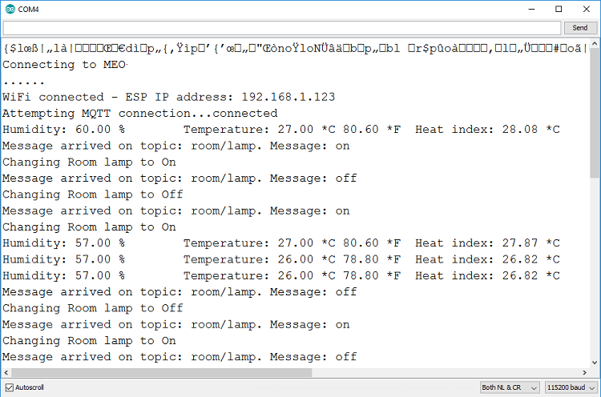
Demonstration
Congratulations! Your project is now completed.
Go to http://your-pi-ip-address/ui to control the ESP with the Node-RED application. You can access your application in any browser on the same network that your Pi (watch the video demonstration below).
The application should look something the figure below.
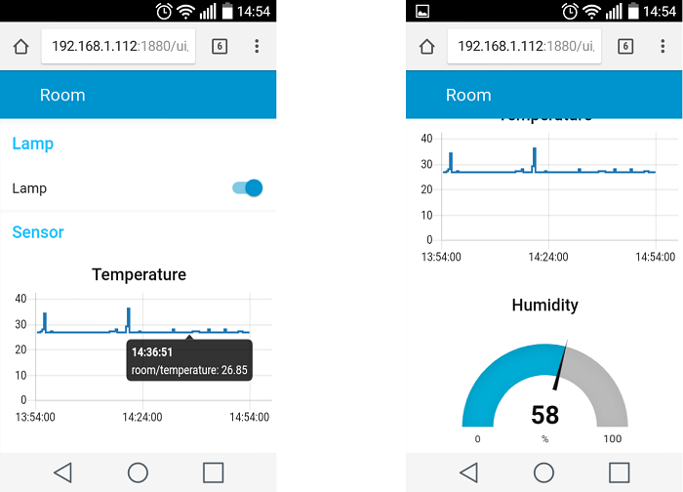
Wrapping up
In this tutorial, we’ve shown you the basic concepts that will allow you to turn on lights and monitor sensors on your ESP8266 using Node-RED and MQTT communication protocol. You can follow these basic steps to build more advanced projects.
We have other MQTT tutorials using other sensors that you may find useful:
- ESP8266 NodeMCU MQTT – Publish BME280 Sensor Readings (Arduino IDE)
- ESP8266 NodeMCU MQTT – Publish DS18B20 Temperature Readings (Arduino IDE)
- ESP8266 NodeMCU MQTT – Publish BME680 Temperature, Humidity, Pressure, and Gas Readings (Arduino IDE)
We hope you’ve found this tutorial useful.
If you like this project and Home Automation make sure you check our eBook: SMART HOME with Raspberry Pi, ESP32, and ESP8266.

